

**Quality Standard for UAL Outreach and the Insights Programme | 2023/24**

Associate Dean of Outreach, Senior Outreach Manager and College Outreach Managers (v4 17/5/23)

**PROCESS MAP**

ELEMENTS ASPECTS AREAS ASPECTS ELEMENTS

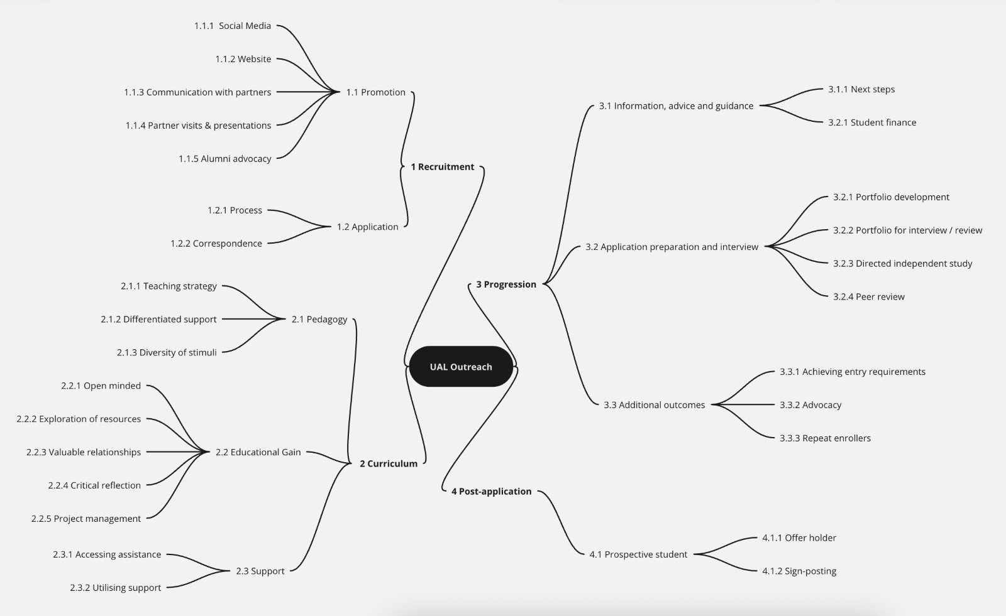

**AREA 1: RECRUITMENT**

|  |  |  |
| --- | --- | --- |
| ASPECT | ELEMENTS | GOLD STANDARD (intended impact): |
| 1.1  Promotion | 1.1.1  Social media | Social media presence creates a strong connection between the Insights programme and high-quality arts education. Social media content makes users curious and stimulates them to explore the Insights section of the UAL website. All prospective students follow Insights on Instagram. |
| 1.1.2  Website | Visitors are stimulated and satisfied by the website content. Prospective students are in no doubt about the high quality of the curriculum and make an informed decision about its suitability for their needs. Eligibility criteria is clear. All prospective students (at whom the provision is targeted) recognise the benefits of joining the Insights programme. Prospective students who are eligible, are confident that they will receive the support needed to equip themselves well during the application process. Students become excited at the prospect of studying at UAL and see the Insights programme as the first step to exploring the potential for a creative future and career. |
| 1.1.3  Communication with partners | Partner teachers / community leads understand the breadth of the Insights programme and the cycle of Insights to support and know how to guide their students to get involved. Teachers are able to develop students’ skills and confidence to enable them to apply to UAL because of Insights. Teachers act as agents and support recruitment by requesting visits, its, referring eligible students, and encouraging and supporting the application process. Teachers relay information back to UAL about improving attainment in their own educational setting. |
| 1.1.4  Partner visits & presentations | Presentations are accessible with engaging information design. Students feel excited at the prospect of engaging in an event outside of their usual education / community setting. They begin to visualise their future self in the creative industries, and they feel part of something new that has clear, simple and accessible routes to move forward to gain a valued and world-class creative career. The range of partners that we reach out to goes beyond only schools and colleges to community organisations. Leaders in these organisations are supported by Outreach and become advocates for Insights at UAL. |
| 1.1.5  Alumni advocacy | Insights alumni, working as Outreach Ambassadors, enable prospective students to see themselves succeeding on the Insights programme and within the creative industry. Prospective students are comfortable to ask questions related to their interests, further study, and future creative careers. |
| 1.2  Application | 1.2.1  Process | The application process is intuitive, informative and student friendly. All applicants feel confident to start and finish the application process, helped by knowing how long it will take, and that they can save and resume their application at any point to seek in-person support from teachers or Outreach staff. The application experience is equitable across a range of digital devices. |
| 1.2.2  Correspondence | Timely and supportive correspondence ensures applicants are aware of the progress of their application and when to expect an outcome. Clear information and guidance is provided to the applicant, including information for parents / guardians, and tone of voice and content is consistent across all UAL colleges. For successful applicants, pre-event correspondence builds excitement and commitment to investing wholeheartedly in the experience. Post-event correspondence allows the programme to grow in response to audience needs and experiences at Insights. |

**AREA 2: CURRICULUM**

|  |  |  |
| --- | --- | --- |
| ASPECT | ELEMENTS | GOLD STANDARD (intended impact): |
| 2.1  Pedagogy | 2.1.1  Teaching Strategy | Students are inspired by professional practitioners and tutors. The conducive working atmosphere created enables students to collaborate effectively with peers, developing their practical skills and cognitive abilities. |
| 2.1.2  Differentiated support | Students are motivated, informed and committed to achieving goals and milestones as a result of their interaction with Insights. They are challenged by the aims and are confident to take risks due to the supportive atmosphere and structured scaffolding of the content delivery. It is the support that is differentiated, not teachers’ expectations of what students can achieve. |
| 2.1.3  Diversity of stimuli | Students experience an active, practical and varied curriculum that draws from a broad decolonised reference base that goes beyond a westernised creative education. |
| 2.2 Educational gain | 2.2.1  Open minded | As a result of Insights, students are curious, open minded and keen to take risks without fear of failure. Students become hungry for new experiences and believe the creative journey to be as important as the final outputs. |
| 2.2.2  Exploration of resources | Students’ creative ideas are stimulated by access to UAL facilities they haven’t encountered before. Students are given access to world-class studio and workshop equipment and resources. |
| 2.2.3  Valuable relationships | The effectiveness of the collaborative work with peers creates bonds and lasting relationships (both during the curriculum periods and at break times whilst on Insights). This learning network gives students a strong sense of belonging and provides support in times of need; but also lays the foundations for a future creative community too. Students use their understanding of connectivism to proactively build their professional networks. |
| 2.2.4  Critical reflection | Students can clearly articulate their journey to date, including how their practice, skills and attitudes have developed. Students’ effective critical reflection skills ensure they know their strengths and where they need to improve; making them effective creative and critical problem-solvers. |
| 2.2.5  Project management | Students are motivated, informed and committed to achieve the goals and milestones they’ve set themselves. They project manage their journey forward well. Students are confident to ask for support with the resources, equipment and materials that they need for independent study. |
| 2.3  Support | 2.3.1  Accessing assistance | Students access timely and appropriate care and support which resolves and/or mitigates their individual challenges. This will include an excellent introduction to the most effective support available within UAL Student Services and Academic Support, including any new targeted on-course support. |
| 2.3.2  Utilising support | Students are encouraged to make use of the support they may be receiving in their own educational settings and to effectively use this on Insights. |

**AREA 3: PROGRESSION**

|  |  |  |
| --- | --- | --- |
| ASPECT | ELEMENTS | GOLD STANDARD (intended impact): |
| 3.1  Information, advice and guidance | 3.1.1  Next steps | Students, supported by parents/guardians, make informed progression choices as a result of their Insights experience and immersion in UAL surroundings. They feel they are going on to be part of something bigger, exciting, yet achievable. A tangible plan for their future life and career becomes realistically attainable. |
| 3.1.2  Student finance | Students understand the financial implications of enrolling on further study and can easily access and receive timely guidance on how to apply for Student Finance England / Student Loan and bursaries and/or scholarships. |
| 3.2  Application preparation and interview | 3.2.1  Portfolio development | Through Insights, students understand the relationship between preliminary work and final outcomes. As a result of this, they focus more on the former. Preliminary work showcases the development of an artistic freedom that involves taking risks and explore exciting ideas. Pressure is taken off final outcomes. Students’ final portfolios evidence this understanding well, to themselves and to recruiters. |
| 3.2.2  Portfolio for interview / review | The Insights experience ensures students make informed decisions about portfolio content, layout, captions, titles, annotation and delivery method (in-person/digital). In addition to this, students gain an understanding of the importance of documenting their work and take responsibility for the process. |
| 3.2.3  Directed independent study | UAL tutors use stimulating briefs that lead students to conduct the sort of valuable self-led projects beyond their school curriculum which are positively received by admissions team. These could include collaborations with members of their network. |
| 3.2.4  Peer review | The small-group and individual tutorials and reviews students take part in ensure they are prepared for the interview experience, as they have repeatedly practised discussing their work and receive supportive challenge. |
| 3.3  Additional outcomes | 3.3.1  Achieving entry requirements | The Insights experience informs students’ creative practice and improves Level-3 school attainment. Students have the option to use Insights activity outputs towards exam submissions and/or Final Major Projects (FMPs) if relevant. |
| 3.3.2  Advocacy | Students become advocates for the Insights experience and go on to influence others from similar backgrounds (including relations/peers etc) to consider previously unexplored options for FE/HE. They want to be a part of UAL’s community and are aware and enthusiastic about the opportunities to take on paid work as an Outreach Ambassador or on the Creative Undergraduate in Schools (CUIS) programme. |
| 3.3.3  Repeat enrollers | Students understand the value of the Insights programme and how it adds to their creative practice. This encourages them to attend as many programmes as possible. |

**AREA 4: POST-APPLICATION**

|  |  |  |
| --- | --- | --- |
| ASPECT | ELEMENTS | GOLD STANDARD (intended impact): |
| 4.1  Prospective student | 4.1.1  Offer holder | A prompt and congratulatory communication is sent to the student with exciting news about opportunities specifically offered to them due to being an Insights alumnus, including information about bursaries and scholarships they are eligible to apply for |
|  | 4.1.2  Sign-posting | Following the offer communication, students can immediately make connections with on-course initiatives and opportunities. They are excited and engaged about the next steps of their journey. |