3 Teaching, learning and assessment
Version 05 04/09/22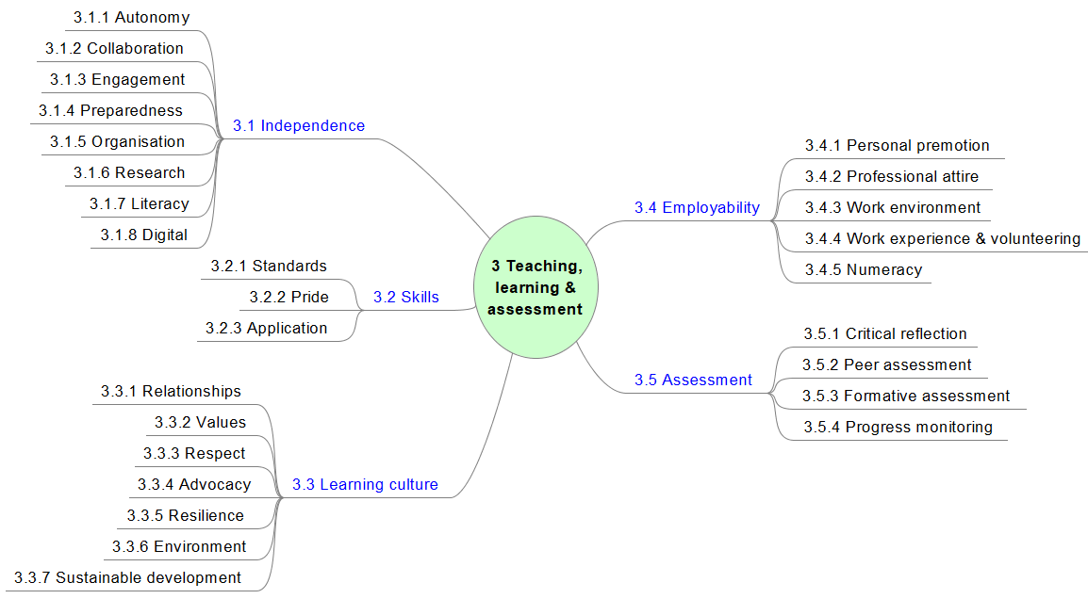
 | Area | 3 Teaching, learning and assessment
Aspect |  | Elements | Gold Standard intended impact:
3.1  Independence |  | 3.1.1  Autonomy | Learners are confident when learning independently. The design of the curriculum, access to varied resources and the approach of staff engages learners and stimulates their curiosity. Learners then make their own discoveries in and between lessons, which deepens their understanding. Learners feel safe to take risks when testing and applying their learning without fear of failure or embarrassment.
 |  | 3.1.2  Collaboration | Learners’ mutual support enables them to learn collaboratively with any member of their group, so benefitting from a wider pool of ideas and perspectives. The sharing of ideas and sense of collaboration promotes curiosity and independent learning. Learners are as likely to note strong learning points from peers as from the teacher. Learners work and communicate effectively as group leaders or team members to achieve mutually agreed goals.
 |  | 3.1.3  Engagement | Learners are excited to learn and explore in lessons and beyond. They demonstrate their motivation through their readiness to learn, engagement in tasks and the personal contributions they can make to their own and others' learning. They work in a rewarding ‘can-do’ environment where a high level of personal investment in learning is the norm. They attend all lessons, are punctual and are advocates and ambassadors for their courses.
 |  | 3.1.4  Preparedness | Learners arrive at college with a ready-to-learn mindset. They have considered the day's work ahead and arrive with all required learning materials, appropriate attire, and all home- and preparation-work completed.
 |  | 3.1.5  Organisation | Learners use their excellent organisational skills to manage their learning and meet all milestones and deadlines. Their motivation, passion and pride is evident in their attitude towards their studies and quality of their work.
 |  | 3.1.6  Research | Learners use research skills well to locate information and extend their knowledge and understanding. Learners grow in confidence when collating information, recording their findings and checking the validity of sources. Learners synthesise, evaluate, compare and present their considered findings effectively. Where appropriate, learners reference their sources to create high quality assignments.
 |  | 3.1.7  Literacy | Learners are articulate and confident in all aspects of their written work, demonstrating effective higher-order critical thinking and reflection skills in different contexts, including the course work, independent study and career planning required of their programme of study.
 |  | 3.1.8  Digital | Learners make full use of all online platforms appropriate to their programme of study through which the college provides its learning resources and educational development. Through their effective online collaboration and communication with peers and staff, learners are always on target, prepared and looking forward to their next learning experience.
3.2  Skills |  | 3.2.1  Standards | Learners use their understanding of tutor expectations and, where appropriate, current industry standards and developments as a benchmark against which they can measure their own performance, progress and ambition. The work ethic and culture developed and promoted by staff (which mirrors industry professional standards) prepares learners effectively for the transition to their next step. Learners communicate professionally with both peers and staff.
 |  | 3.2.2  Pride | Learners take pride in completing work to a high standard. They communicate effectively their interest in, and passion for, their subject. Learners give detailed, terminology-rich explanations about their work and their approach to its development.
 |  | 3.2.3  Application | Learners demonstrate a deep understanding and mastery of their vocational skills. Their understanding of how to learn ensures they can apply this mastery to new and novel situations. Learners understand the relevance of all elements of their programme to their progression opportunities and aspirations, and use this understanding to succeed in assessments.
3.3  Learning culture |  | 3.3.1  Relationships | Learners enjoy strong personal relationships with all of their peers and staff, which acts as an additional motivator for attendance and punctuality. Their high level of social confidence comes from their belief that the classroom environment is one in which it is safe to make mistakes. They feel comfortable in asking questions of their peers and their teachers and to express and explore their views in a safe and friendly environment without fear of reprisals. This enables learners to take risks and explore skills and areas of work outside of their comfort zones. Learners feel supported and valued, promoting motivation, and encouraging them to achieve their best.
 |  | 3.3.2  Values | Learners embrace the underlying principles of British Values and demonstrate these within the classroom to enhance their own and their peers' positive learning experiences. The learning environment is conducive to cooperation and peer support. Learners relate British Values to their industry and embed them in their practice.
 |  | 3.3.3  Respect | Learners value their own and other differences, whatever these may be, and continually demonstrate their respect for everyone they work with.
 |  | 3.3.4  Advocacy | Learners aspire to be valued by both their learning and cultural communities. They are ambassadors for the college and effective advocates for their programme of study.
 |  | 3.3.5  Resilience | Learners are resilient, self-confident and consciously support each other, fostering a patient and inclusive environment. Learners’ recognise the ‘plateaus’ typical of any learning journey and use effective strategies to overcome them. They achieve all of their milestones and goals, never getting behind with their work. Staff use coaching and, where necessary, constructive feedback well so that learners are not daunted by the onward journey.
 |  | 3.3.6  Environment | Learning spaces are safe, attractive and comfortable and foster both collaborative and independent learning. Learners are safe inside the provider’s premises and online where high standards of behaviour are demonstrated both inside and outside of the classroom.
 |  | 3.3.7  Sustainable development | Learners embrace the underlying principles of environmental sustainability (eg. UK Net Zero Strategy, UK gov strategies to reduce single use plastics) and demonstrate understanding and competence with current and (where relevant) future sustainability practices relevant to both their daily lives and their area of vocational study.
3.4  Employability |  | 3.4.1  Personal promotion | Learners have excellent inter-personal skills and present themselves effectively, persuading and influencing others with confidence. They understand their own unique attributes and sell themselves effectively.
 |  | 3.4.2  Professional attire | Where appropriate, learners take pride in wearing the uniform or attire associated with their discipline. Learners value how their clothing builds a sense of community and shared experience, while keeping them safe when in a work-place environment.
 |  | 3.4.3  Work environment | In preparation for real or simulated work experience, learners develop their awareness of the contributions they can make to employers and articulate well how work experience will help inform their progression decisions and opportunities.
 |  | 3.4.4 Work experience & volunteering | Learners are proactive in seeking learning experiences outside of college. They plan, and capitalise effectively on, work-related and/or volunteering opportunities. Learners drive their placements. They plan and prepare effectively for observations and tutor visits and showcase their skills in the workplace and/or volunteering setting. Learners’ understanding of British Values enables them to make an informed judgement about the effectiveness of their work experience and/or volunteering setting.
 |  | 3.4.5  Numeracy | When working or solving problems within their vocational subjects, learners use their mathematical ‘toolkit’ of skills to move forward efficiently. Learners’ understanding of the relevance to everyday life of their maths ‘toolkit’ enables them to enjoy the development of their mathematical skills.

3.5  Assessment | 3.5.1  Critical reflection | Learners use their understanding of (where appropriate) high-grade assessment criteria, industry standards and higher-order thinking skills to develop a clear understanding of 'quality'. Learners use this understanding to evaluate the effectiveness of their own work. Learners then use a range of effective 'editing' techniques to improve the quality of their work before submitting it for assessment.
 | 3.5.2  Peer assessment | Learners use peer assessment to refine their objective evaluation skills and gain deeper insights into alternative solutions to the learning challenges. Learners use excellent communication skills to ask questions of others and offer developmental ideas for consideration.
 | 3.5.3  Formative assessment | Learners articulate well the progress they have made in a lesson, including the next, and/or remaining, learning challenges to be addressed. Learners' ability to understand how to learn well (metacognition) ensures they progress quickly in all lessons.
 | 3.5.4  Progress monitoring | Learners use all available data to evaluate their progress. They describe clearly the barriers that have held them back and use this learning to mitigate any potential barriers that might make them underperform in the future. Learners are proud of their achievements.

