Assessment and the Art of Lazy Teaching

## Navigate to the following webpage in preparation for the session:

[www.ccqi.org.uk/assessmentresources](http://www.ccqi.org.uk/assessmentresources)

Password: aalt7195

## Using Zoom

### Cameras on

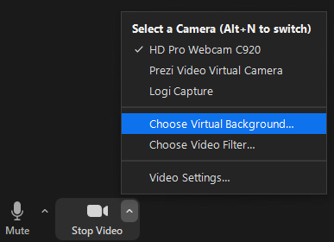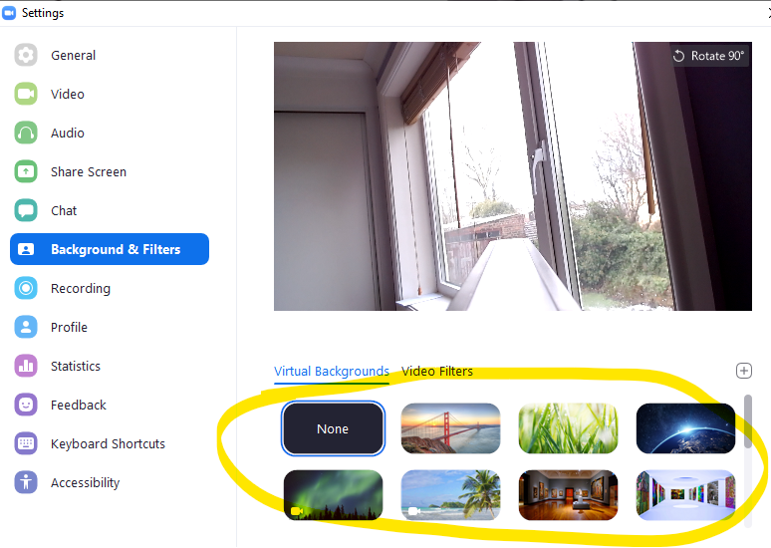This is a **cameras on** session using Zoom. Feel free to use a 'virtual background' if you would prefer not to share your surroundings. To turn on a virtual background, click on the '**^**' symbol to the right of the video camera icon (bottom left corner), then click on 'Choose Virtual Background'. Next, click on 'Backgrounds and Filters' and select a background. You may be asked to download the 'Smart virtual package'. (If you are using an older version of Windows, you may need to click the '**+**' sign (circling in red) and add your own image.)

### Your name

Please ensure you type the name you wish the host to use when referring to you. To do this, hover over the video image of yourself and click on the three dots that appear in the top right-hand corner. Then select 'Rename'.

### Breakout rooms

While in a breakout room, if you'd like to ask a question, please click 'More' and then 'Ask for help'.

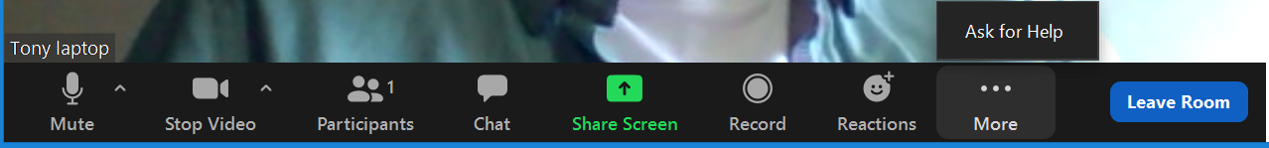

##### Useful Zoom quick keys

Alt + y Raise your hand

Alt + a Mute/unmute audio

Alt F2 Switch to gallery view

## Define Assessment

## Silent Minute - Write a question, comment or implication

What do you think so far?

What are the implications for your practice or that of your department or organisation’s systems?

Do you have any questions so far?

|  |  |  |  |  |  |
| --- | --- | --- | --- | --- | --- |
| **Criteria** | **Self assessment** | | | **Target** | **By (date)** |
| **R** | **A** | **G** |
| I use a large and **varied range of formative assessment strategies** that ensure learners evaluate their current learning and set themselves a specific next step. |  |  |  |  |  |
| My formative assessment strategies have a strong focus on the development of my learners’ **expert, independent learning skills**. |  |  |  |  |  |
| I make use of information generated by my formative assessment strategies in **my impact-evaluation of my lessons** and to inform the learning outcomes and teaching strategies of future lessons. |  |  |  |  |  |
| My **learning outcomes** set out clearly how learners will be *different* as a result of my lessons, rather than what they will *do* in the lessons. Each one contains a label, verb and outcome. |  |  |  |  |  |
| The way I **work with individual learners** continually builds their independence of me, rather than a dependence on me. |  |  |  |  |  |
| **Further actions?** | | | | |  |
|  | | | | |  |
|  | | | | |  |
|  | | | | |  |
|  | | | | |  |

## Assessment Strategy Log

|  |  |  |
| --- | --- | --- |
| **No.** | **Assessment title** | **Notes** |
|  |  |  |
|  |  |  |
|  |  |  |
|  |  |  |
|  |  |  |
|  |  |  |
|  |  |  |
|  |  |  |
|  |  |  |
|  |  |  |

## Community Challenge

The aim of the game is to recommend to your Quality Community (the other players) the best assessment strategy for each lesson scenario given in the **Community Challenge Cards**.

1. A hand of five ***Fifty Shades of Assessment*** (FSoA) cards has been dealt automatically to each player here: [www.ccqi.org.uk/50shades2](http://www.ccqi.org.uk/50shades2)
2. The ***Community Challenge*** (CC) cards are at the top of your screen. There are 50 in all each describing a different type of lesson.
3. Each player should read through all five of their cards in preparation for play. All players have different FSoA cards. Please **do not** refresh your browser, otherwise your cards will change.
4. You can begin with CC card #1, or randomly select a card from the pack by: clicking the spots underneath the care, or using the green arrows to the left- and right-hand sides of the card. The important rule is that all players are looking at the same CC card. Just check the number in the top right corner.
5. Each player considers which of their assessment strategies best meets the ***Community Challenge***.
6. When everyone is ready, each player describes their chosen assessment strategy and explains why it should be considered the best in meeting the ***Community Challenge*** lesson.
7. The group then debates the assessment suggestions and declares a winner. Two points are awarded for an outright win, or one point to each player if there is a draw. Scores are recorded on the score sheet below. **Each winning FSoA card can only be played once.**
8. Each player should note in their ***Assessment Strategy Log*** the titles and reference numbers (bottom right-hand corner) of any cards they would like to consider further.
9. After **three** rounds, players may change all five FSoA cards by refreshing their browser (F5).
10. The game ends when time is called. When you receive the 5-minute warning that the game will be ending, please finish your round as soon as you can, total your scores and announce the winner! The winner is the player with the most points.

|  |  |  |  |  |
| --- | --- | --- | --- | --- |
| **Round** | **Player 1 name** | **Player 2 name** | **Player 3 name** | **Player 4 name** |
|  |  |  |  |
| 1 |  |  |  |  |
| 2 |  |  |  |  |
| 3 |  |  |  |  |
| 4 |  |  |  |  |
| 5 |  |  |  |  |
| 6 |  |  |  |  |
| 7 |  |  |  |  |
| 8 |  |  |  |  |
| 9 |  |  |  |  |
| 10 |  |  |  |  |
| **Final total** |  |  |  |  |

## Research Lesson

Consider a learning experience you are about to deliver in which you could experiment with integrating a number of the strategies you have listed in your Assessment Strategies Log.

### Lesson title

### Learning outcomes

### Assessment Strategies (from your Assessment Strategies Log)

### How will these strategies change your planned teaching strategies



Scan QR code or use the link to access all session resources.

http://ccqi.org.uk/resources/assessmentresources

Password: aalt7195