Learning Motivation

## Please navigate to the following webpage in preparation for the session:

<http://ccqi.org.uk/resources/motivation-and-retention>

Password: mar4479

### Cameras on

This is a **cameras on** session using Zoom. Feel free to use a 'virtual background' if you would prefer not to share your surroundings. To turn on a virtual background, click on the '**^**' symbol to the right of the video camera icon (bottom left corner), then click on 'Choose Virtual Background'. Next, click on 'Backgrounds and Filters' and select a background. You may be asked to download the 'Smart virtual package'. (If you are using an older version of Windows, you may need to click the '**+**' sign (circling in red) and add your own image.)

### 

### Your name

Please ensure you type the name you wish the host to use when referring to you. To do this, hover over the video image of yourself and click on the three dots that appear in the top right-hand corner. Then select 'Rename'.

### Breakout rooms

While in a breakout room, if you'd like to ask a question, please click 'More' and then 'Ask for help'.



##### Useful Zoom quick keys

Alt + y Raise your hand

Alt + a Mute/unmute audio

Alt F2 Switch to gallery view

##### Speaker view

Set the *view* option to 'Speaker view' in the top right corner of your Zoom window.

Learning outcomes

By the end of the session, delegates will be able to:

* **list** the **least motivational** **aspects** of **provision**
* **identify** the **least motivational periods** in the **academic year/scheme of work**
* **use** their understanding of the **difference between an issue and a symptom** to **plan** **quality improvement activities**.
* **use** the **Formula for Happiness** to **plan** an **unmissable learning experience**
* **use** **intellectual temptation** to **engage learners**

## Main motivation challenge

In which aspect/s of your course are your learners least motivated to succeed?

Please don’t write English or maths. If you’re an English or maths teacher, please try to identify specific aspects of your courses that learners find most difficult to get excited about.

## Root-cause issue

Why do your learners find motivation more difficult towards the aspects of provision you have identified?

Use the 'Five Whys' to drill down to the root cause by simply asking 'So why's that, then?' over and over.

## The 'thin' scheme of work

1. If possible, plot your root-cause issue onto this slim scheme of work/timeline.

2. Mark with an X the point/s in the year when motivation is generally lowest.

3. Mark with a 😊 the weeks in which something unmissably exciting happens that learners are continually looking forward to.

4. Score each half term out of 10 for excitement – 10 being unmissably exciting and stimulating.

|  |  |
| --- | --- |
| 1 | September – **Term 1** |
| 2 |  |
| 3 |  |
| 4 |  |
| 5 | October |
| 6 |  |
| 7 |  |
| 8 |  |
| Half-term holiday | |
| 9 | November |
| 10 |  |
| 11 |  |
| 12 |  |
| 13 | December |
| 14 |  |
| 15 |  |
| End-of-term holiday | |
| 16 | January – **Term 2** |
| 17 |  |
| 18 |  |
| 19 |  |
| 20 | February |
| 21 |  |
| Half-term holiday | |
| 22 |  |
| 23 | March |
| 24 |  |
| 25 |  |
| 26 |  |
| 27 | April |
| 28 |  |
| End-of-term holiday | |
| 29 | **Term 3** |
| 30 | May |
| 31 |  |
| 32 |  |
| Half-term holiday | |
| 33 | June |
| 34 |  |
| 35 |  |
| 36 |  |

# Creating zone experiences using the Formula for Happiness

How could you use Mihaly Czikszentmihalyi’s formula for happiness to create something new and exciting for your learners?

Your task is to develop a new lesson, or reinvigorate an old one, with a primary aim of getting all of your learners ‘into the zone’ for a learning experience they will never forget. Please do not simply restate something you already do.

To experience being ‘in the zone’ (‘optimal flow’), we need to satisfy one, more or all of the following conditions:

1. Enjoyment normally occurs when we confront tasks we have a chance of completing.

2. We must be able to concentrate on what we are doing.

3. Concentration is usually possible because the task has clear goals, and

4. Provides immediate feedback.

5. One acts with a deep but effortless involvement that removes from awareness the worries and frustrations of everyday life.

6. Enjoyable experiences allow people to exercise a sense of control over their actions.

7. Concern for the self disappears, yet paradoxically the sense of self emerges stronger after the experience is over.

8. The sense of the duration of time is altered; hours pass by in minutes, and minutes can stretch out to seem like hours.

### Rules for this task

* Think huge, a caricature perhaps of what might be considered normal practice.
* For at least the duration of this session, do not allow any discussion on the practicalities or cost of your ideas.
* Make yourselves laugh with your suggestions.

Ideas Plan – The zone experience

My huge idea is…

My learners be 'different' afterwards in the following ways:

I will know I've achieved this 'difference' by observing:

To make this huge idea a reality I would have to…

To get the ball rolling by next week, I need to…

I aim to have fully developed my idea by: *(date)*

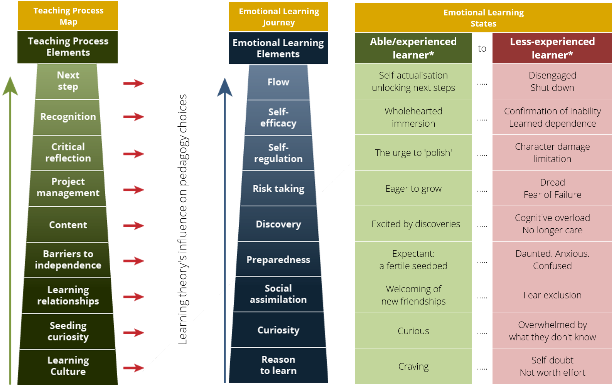

## A Unified Theory of Learning

# The Learning Momentum graph

Learning momentum

Time

Newcastle College

The learning momentum graph

Self-evaluation of teaching impact

The issues causing lack of motivation

Designing a zone experience continued

cont..

Designing a zone experience

Curiosity

Coffee

The formula for happiness

Highs on the scheme of work

Lows on the scheme of work

Issue or Symptom game

Session aims

Paired conversations

|  |  |  |
| --- | --- | --- |
| **Motivation issue you want to resolve (from page 1)** | **Ideas for improvement** | **By when?** |
|  |  |  |