Perfecting self-assessment writing

*Understanding why it so often goes wrong – and how to put it right*

### Timing

This session lasts 3hr30 and the break should be at around 1hr30.

### Resource website

You'll find the learning outcomes and session resources on the link below – password psaw5564: [www.ccqi.org.uk/resources/perfecting-self-assessment-writing](http://www.ccqi.org.uk/resources/perfecting-self-assessment-writing)

### Handout

I recommend that you print the handout or have it available on a separate monitor or computer. The session centres on the notes you will make.

## Zoom

Please join the meeting using the Zoom app, which can be downloaded free from here: <https://zoom.us/download>. Please be aware that joining through a browser will prevent you from taking part in some of the collaborative activities.

### This is a 'cameras on' session

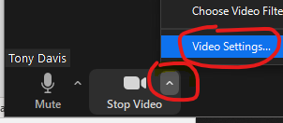We would like to thank everyone in advance of this session for their full engagement with the tasks and other delegates. **Please join with cameras on**. Feel free to use a 'virtual background' if you would prefer not to share your surroundings. You may need to click the '+' to download.

### Your name

Please ensure you type the name you wish the host to use when referring to you. First names and surname initial are a good minimum. Right click on your picture and select 'rename'.

### Breakout rooms



While in a breakout room, if you'd like to ask a question, please click 'Ask for help'.

### Whiteboards

To annotate a whiteboard, click 'View Options' and 'Annotate' to open your annotation toolbar.

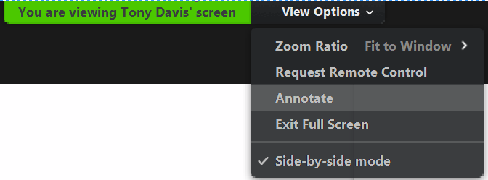

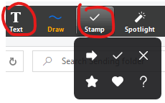Click on the 'Text' tool to type onto the screen. Your typing will only be public once you: *click away from your typing.*

We will also be using the 'Stamp' tool.

### Quick keys

|  |
| --- |
| Spacebar Temporarily unmute while pressed  Alt + a Mute/unmute your audio |
| Alt + y Raise your hand |

For a self-assessment report to work its magic it has to meet one essential criteria:

**Key message**

* it should ignore the third-party audience

If staff have the funders or the inspectorate in mind when working on their SAR it will:

* skew the writing and make much of it redundant
* undermine the development plan
* flaw the whole process by turning it into a bureaucratic exercise.

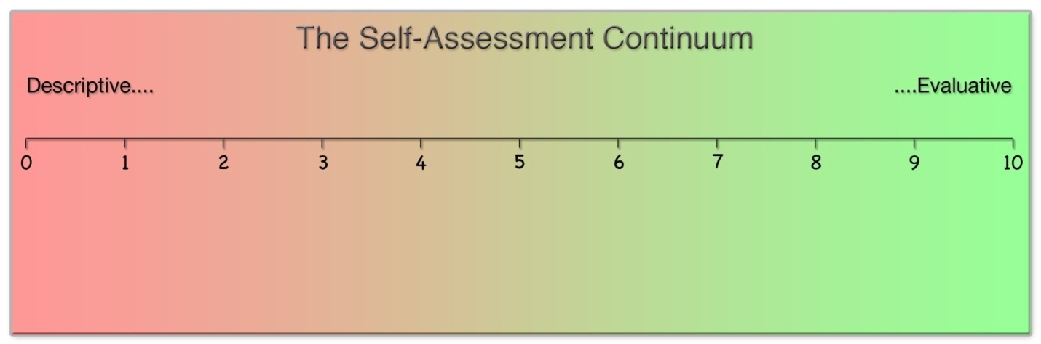

## Common issues

Writing judgements which are:

|  |  |
| --- | --- |
| * Relative **R** * Masking **M** * Not Learner Centred **NLC** |  |
| * Systems focussed **S** * Descriptive **D** |  |

## Relative

* *“Improved use of learner feedback”*
  + *“more effective”*
  + *“significantly improved”*
  + *“much progress”*

The issue is not the writing of the relative statements themselves, but that they often stop the writer from making a clear judgement of quality:  *how good is this aspect of provision* ***now***.

|  |  |
| --- | --- |
| **Self-Assessment Report Extracts** | **Identify the common issues**  R – Relative  M – Masking  NLC – Not learner centred  S – Systems  D – Descriptive |
| A vast improvement on previous year's performance, both in numbers of learners enrolled onto IT courses and on the number of achievements and success rates.  Learners are given the opportunity to undertake SFL programmes before enrolling onto IT programmes to get used to the learning environment, this has resulted in learners achieving more than they originally expected, and feeling a lot more confident with IT courses when doing them. |  |
| Greater emphasis is being placed this year on Centre Health Visits by Managers, these will be collated on a quarterly basis and used to enhance the development plan of the business. |  |
| Highly qualified and experienced tutor support available throughout our whole network of centres. We use Google Chat as a powerful communication tool to give all tutors full access at the click of a button to several L5 and L6 tutors, as well as all managers.  Staff development is a key area of development and we continuously strive to ensure that, where possible, all staff are supported through whatever training they would like or need for the purpose of their work.  In addition, towards the end of this academic year we recruited a Staff Training Manager whose primary function is to concentrate solely on the development of our staff, providing specific and relevant training programmes, both internal and external. |  |

## Masking

* *“The development of an Operations Directory through the national VLE has improved access for staff to policy documents and procedures.”*

In breakout groups, please discuss the issue that might have led to this action.

|  |
| --- |
|  |

Other 'masking' terms:

* *“inconsistent”*
* *“not enough”*
* *“underdeveloped”*

Masking statements provide a smoke screen for aspects of provision the writer wants to hide.

## Not learner centred

* *“Clear strategic vision from the managing director and company owner”*
  + *“committed staff”*
  + *“excellent relationships with most employers”*
  + *“senior management membership of national organisations”*

Judgements which do not focus on the learner make you ask the ‘so what’ question: *so what is the impact on the learner?*

## Systems focussed

* *“Regular, relevant training packages have been offered, or are planned, for all assessment staff and managers covering topics such as: equality and diversity, IAG, H&S, child protection etc.”*
  + *“particularly flexible delivery of training and assessment”*
  + *“good management information system”*
  + *“good staff development”*

Just because something takes a lot of effort doesn’t mean it makes any difference to the learning experience. Systems judgements can result in rewarding bureaucracy.

## Descriptive judgements

**Key message**

* Promote bureaucracy
* Prevents staff from seeing the way forward clearly

## Self-assessment rubric

Rewrite the following judgement to sound like a clear strength:

*“Learner surveys and evaluations are carried out periodically, after induction, bimonthly and at the end of programme.”*

|  |
| --- |
|  |

A judgement has a non-negotiable format.

**Key message**

To be effective it must have two components:

|  |  |  |
| --- | --- | --- |
|  |  |  |

When a judgement word is added to a descriptive sentence, magic happens:

“*learners progress from qualification to qualification”*

learners’ progression to further qualifications is **good**.

What is the magic that has just happened?

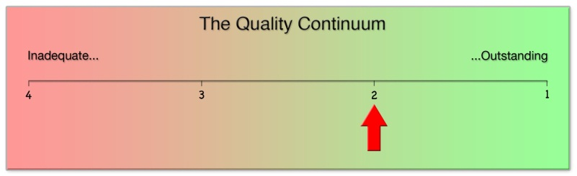

## Task 1 - Hunting the issues

Search sections of your self-assessment report for evidence of any of the five typical writing issues.  Annotate your document using the labels below:

* Relative                                   **R**
* Masking                                  **M**
* Not Learner Centred            **NLC**
* Systems focussed                  **S**
* Descriptive                             **D**

If you cannot find any examples of the above issues, then please congratulate yourself on having potentially written some excellent self-assessment text!

As the starting point for Task 2, please identify any ***Areas for Improvement*** textthat you would like to rewrite (if, indeed, you have any).

## Task 2 - Issue rewrite

1. Open the following page: [www.ccqi.org.uk/SARresources](http://www.ccqi.org.uk/SARresources)
2. Click on Tasks 2 – Hunting and resolving the issues
3. Claim a row in the wiki by typing your initials in column 1.
4. Type or copy the ***Area for Improvement*** text to be rewritten into column 3. **Please don't write into column 4 until directed.**
5. In column 2, add the code for the issue/s you feel need to be addressed:

**R** = Relative; **M** = Masking; **NCL** = Not Learner Centred; **S** = Systems focused; **D** = Descriptive.

Please be aware that this is a Google Doc, so there is no save button. Take care not to overwrite anyone else's text as there is no undo - all changes are saved immediately.

## Task 3 – Good judgement rewrite

1. Open the following page: [www.ccqi.org.uk/SARresources](http://www.ccqi.org.uk/SARresources)
2. Click on Tasks 3 – Good judgement rewrite
3. Claim a row by adding your initials to column 1.
4. Add your ‘strength' judgement to column 4 *[this should be grade 2 'good', definitely not outstanding]*. Add the ‘Aspect’ and ‘Element’ headings to columns 2 and 3.
5. Edit the sentences to polish your text.
6. Complete the judgement in column 7. **Only add the ‘however’ and ‘issue’ when directed.**

# Task 2: Issue rewrite

|  |  |  |  |  |  |
| --- | --- | --- | --- | --- | --- |
| * Key | R = Relative | M = Masking | NCL = Not Learner Centred | S = Systems focused | D = Descriptive |

|  |  |  |
| --- | --- | --- |
| **Type of issue:**  **R, M, NLC, S or D\*** | **Paste/type the sentence/s to be rewritten** | **Edited text (You will need to make this up.)** |
| Example 1 - Issue | | |
| R, M, D  No root-cause issue | 'In the few centres where most learners have low prior attainment, there has not been a significant change in the way the curriculum is delivered to accommodate individual learners’ needs.' | Planning to meet individual learners' needs is **poor**. Preparation for initial assessment is **ineffective** resulting in **poor** engagement with the process by learners. Results of initial assessment, then, **are not representative**. As these results are not trusted by teachers, learners' starting points are not taken into account when planning lessons, which then fail to meet individuals' needs.  **Issues**:   * **Ineffective** preparation for initial assessment * **Insufficient** use of initial assessment results to plan learning |
| Example 2 - Issue | | |
| M, S  No root-cause issue | 'Teachers do not give learners sufficient feedback to enable them to understand what they should do next.' | The majority of teachers have **insufficient** formative assessment strategies on which to draw. Too often, assessment strategies are **inappropriately** teacher-centred, so creating dependency on them, rather than independence of them. Learners' independent critical thinking skills **require improvement**. These issues **have not** been identified in observation records.  **Issues:**   * **Insufficient** planning for and use of learner-centred formative assessment strategies * **Insufficient** focus of the observation process on evaluating learning impact rather than auditing teacher activity. |
|  |  |  |

# Task 3: Good judgement rewrite

|  |  |  |  |  |  |  |  |  |  |  |
| --- | --- | --- | --- | --- | --- | --- | --- | --- | --- | --- |
| **Area:** | | **4. Learner support** | | |  | |  | |  |  |
| Aspect | | Element/  issue | | Impact analysis | Evidence | | Impact judgement  & issues/reasons not outstanding | |
| Peer support | | Study-support groups | | The use of peer study-support groups is now the cultural norm across most of the curriculum area. Where used, learners report that the sharing of their learning challenges in a safe environment with other learners has built their confidence to contribute authoritatively in lessons. Learners motivate each other effectively to attend both their group’s meetings and all lessons. Attainment (progress against expectation) in subjects where the strategy is used is outstanding, as is the achievement of high grades in assessments. | Study-support group reviews.  Learning management records. | | **Good** use of study-support groups to improve progress and attainment.    **However**,  **Issue:** | |
|  | |  | |  |  | |  | |

## The Good Bullet However Test

**Key message**

  Find a grade 2, good, judgement in your text

* Have you written a ‘however’ at the end of the paragraph?

If you haven’t:

* this aspect of your provision may not improve
* your self-assessment report is not a roadmap to outstanding.

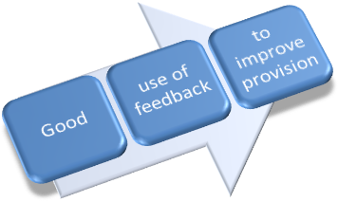

Judgement Subject Impact

And you risk a weakness bullet such as:

* *‘overly descriptive and insufficiently evaluative self assessment’*

**Essential rubric**

* Ignore the third-party audience
* Ask the ‘So what?’ question and concentrate on *learner impact*
* Avoid the five key errors
* Write: judgement, impact, judgement, impact…
* Apply this sentence to everything you write:
  + *What have I learnt from what I’ve just written?*

When done correctly, self assessment is a learning experience for everyone.

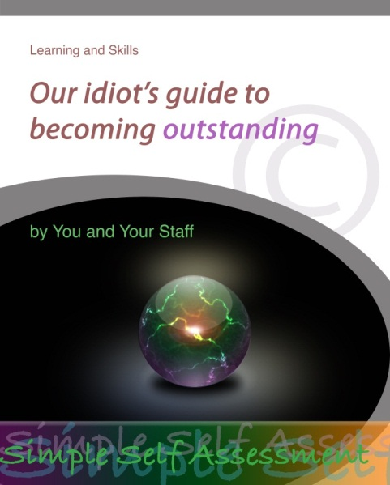A great self-assessment report is your manual on how to become outstanding at every aspect of your provision.

Self assessment can no longer be

a *retrospective* exercise completed once a year focusing on historic data.

It has to be a *live* process that

**improves provision now using low-level, volatile, live data**.

## Self-assessment next steps

* Check your SAR
  + Does it avoid the five errors?
  + Is the analysis and evaluation of impact on learning the central focus of each statement?
  + Does it cover the whole of the learner’s journey?
  + Are all learners referred to in every analysis?
  + Are all judgements of 'good' followed by a 'however' that states what is holding that element back from being outstanding?
* In light of the above, edit your SAR as required.
* Add a reference number to every issue and ‘however’.

## Self-Assessment online training sessions

1. Perfecting self-assessment writing
2. Data Springboard
3. Perfecting development plan writing
4. Introduction to the CCQI Self-Assessment Strategy
5. Using the CCQI Self-Assessment Strategy

Please see [www.ccqi.org.uk/consultancy-support/live-self-assessment](http://www.ccqi.org.uk/consultancy-support/live-self-assessment) for more details.

## onlineteachertraining.red

In Autumn 2021, CCQI will be launching *www.onlineteachertraining.red*. This new website will provide online training with a difference. It's focus will be on independent, yet collaborative, research-focused learning and improvement.

If you would like to be notified of the formal launch, do please drop us as line at

[tony@ccqi.org.uk](mailto:tony@ccqi.org.uk)

## Session resources

All of the resources to support this session can be found on the Centre for Creative Quality Improvement website:

<https://ccqi.org.uk/resources/perfecting-self-assessment-writing>

To access the resources you will need the following password: psaw5564.